**Activity main goal**

*In this activity the student will expand the knowledge explained in class about Business Information Management Systems, using at user level and manually one of the applications to manage business information, then automate certain tasks through the interface XML and with the xPath element locators. The learning outcome associated with this activity is:*

**1.** Treballa amb sistemes empresarials de gestió d’informació realitzant tasques d’importació, integració, assegurament i extracció de la informació.

**Activity evaluation**

*This activity deals with the following curriculum evaluating criteria:*

**1.3-** Instal·la aplicacions de gestió empresarial.

**1.4-** Configura i adapta les aplicacions.

**1.5-** Estableix i verifica l’accés segur a la informació.

**1.6-** Genera informes.

**1.7-** Realitza tasques d’integració amb aplicacions ofimàtiques.

**1.8-** Realitza procediments d’extracció d’informació per al seu tractament i incorporació a diversos sistemes.

**1.9-** Realitza tasques d’assistència i resolució d’incidències.

**1.10-** Elabora documents relatius a l’explotació de l’aplicació.

*A* ***".zip" document is delivered, which will contain a PDF document and an HTML file*** *in the virtual classroom environment in which the relevant answers will be included:*

* *PDF: Written answers and screenshots of the actions taken.*
* *HTML: Test Suite that will include the different Test Houses correctly differentiated and with the exposed content.*

*Students will receive the review and grading of the work in the same virtual environment.*

*In conjunction with this activity, an individual written test in the classroom is also planned later.*

*In case of not passing the activity (obtaining a grade lower than 5), the recovery will consist of the realization and delivery of the same in the second call.*

*However, it will be necessary to show the teacher the real operation of the points that can be asked of the activity during the development of the classes to be able to make a better follow-up and observations of the progress of the learning process.*

**Timing, space and resources**

*This activity will be carried out by the students during* ***4 hours*** *in the assigned workspace.*

*The workspace is the classroom assigned to the class group. The classrooms have:*

* *Computers and Internet connection by wire and/or wifi.*
* *Multimedia projector.*

*Each class group has a Moodle digital environment per unit of training within the module and, in our case, the Google drive tool on:*

* *The bulk of the course materials will be available.*
* *They will be informed of the practices and work to be performed, as well as the delivery times.*
* *They must submit all the work and practices requested.*
* *They will be able to track your grades.*
* *They will be able to communicate with the teacher and the rest of the classmates.*

*The technical resources to consult are indicated in the section of the “webgrafía”, which the students can find them directly on the Internet, or in the library of the center.*

**Activity description**

In this document you can find a series of tasks to be solved individually. Try to be the one who does them completely, with the least help from colleagues, but by consulting all the necessary sources on the internet or other means, and reasoning how they are solved.

This activity is based on Odoo (OpenERP) but you can use any other ERP with a web interface.

### *Task to do:*

### 

**1.-** Check that you have a **virtual machine** available with a **GNU/Linux distribution** (preferably a server distribution that you used in M1), and you may connect to it.

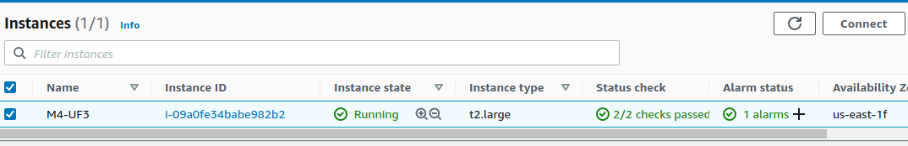

**2.-** We will use ***Ubuntu terminal*** to install the application, follow the instructions in the videos:

| Odoo in AWS [Part 1] →<https://www.youtube.com/watch?v=WG6sDoXDwdY>  Odoo in AWS [Part 2] →<https://www.youtube.com/watch?v=HEwhhSaXIP0> |
| --- |

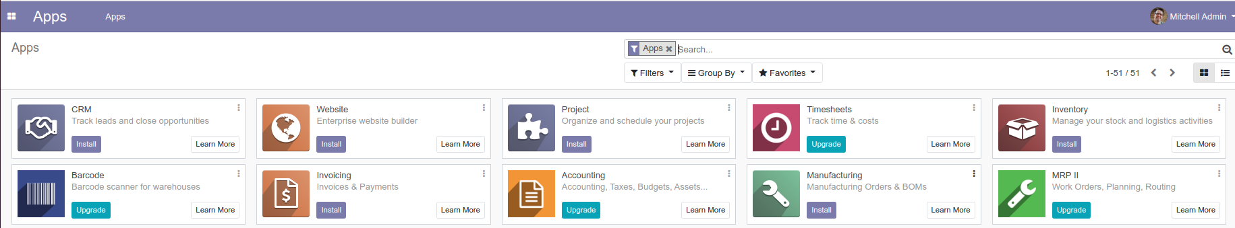

* To access Odoo, type in your browser [**http://SERVER_IP:8069**](http://server_ip:8069/).
* To recover passwords: type this URL: [**http://SERVER_IP:8069**/web/database/manager](http://server_ip:8069/web/database/manager).
* When you create your company, **select** the **checkbox** that it loads **test data**. It is not mandatory, but highly recommended. **Remember all the data you type**, as this will be your account with the admin user.

**3.- (PDF) Customize Odoo** for the company of your dreams. Click on the squares (top left button) → Settings → User & Companies. Invent it, and **fill in all the fields** to have a better defined social entity within the environment. **Take a screenshot** that reflects your changes. **Add a corporate image** as well, to be seen on the login page.

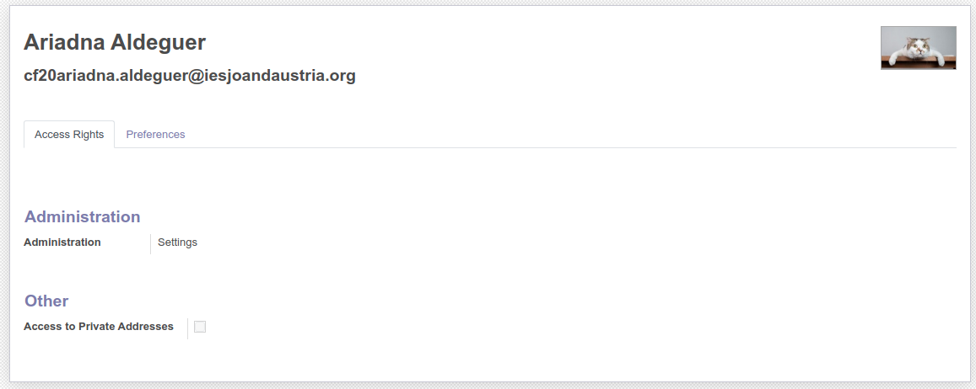

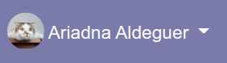

**4.- (PDF)** To establish and verify secure access to the information, we will **manually install** the following **Apps modules**. With that, in addition, we can check that depending on the **type of user**, it is possible to access one information or another.

Find and install (at least) the following modules that will be needed:

* 1. Module to be able to conduct Email marketing campaigns, implement FAQs and customer complaints → Email marketing
  2. Module to build a website from the ERP. → Website
  3. Module to sell the products on the website (different from the previous one). → eCommerce
  4. Module to control the entire process of a sale, to be able to carry out accounting and invoicing. → Sales
  5. Module to manage your Employees (workers). → Employees
  6. To be able to manage all the workers of the company (CRM). → CRM

Take a screenshot with all the modules installed.

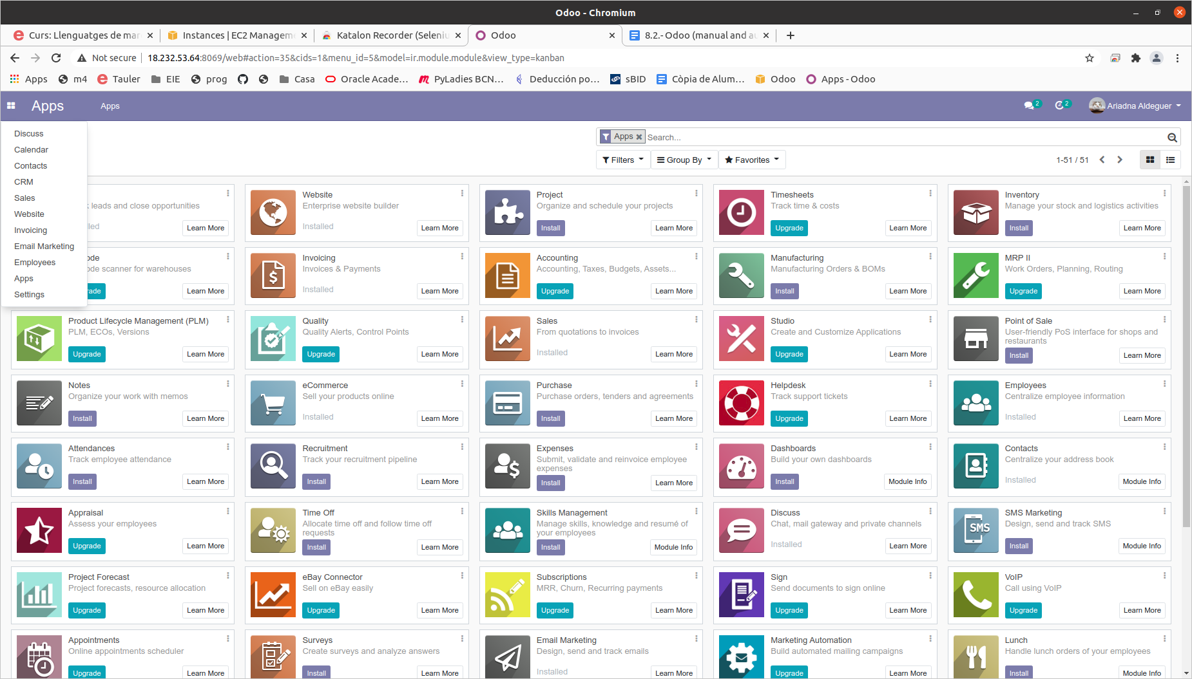

**5.- (PDF) Manually create** a new workers department. Call it ***M4-UF3***, have the parent department as Administration, and if you want, assign a person in charge of the listing. Take a **screenshot** that reflects your changes.

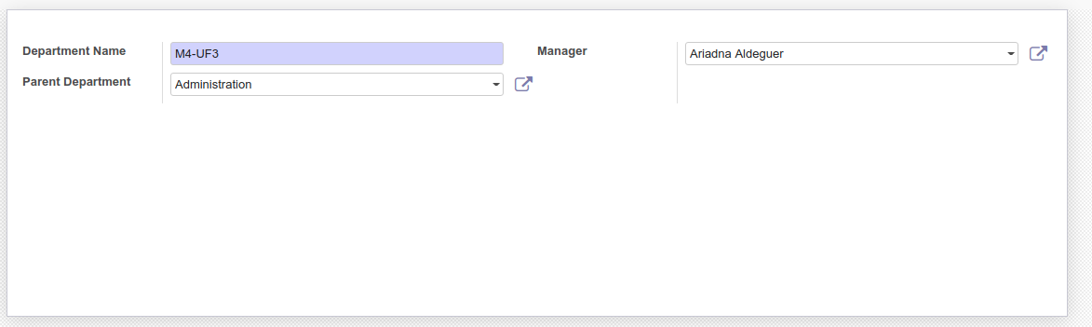

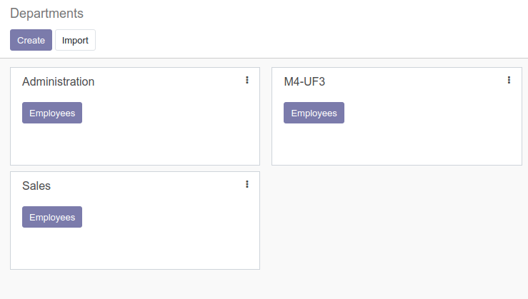

**6.- (PDF)** Simulate **2 sales manually**, of those **products** that you **created earlier**, or that appeared by default with Odoo upload values. Take a **screenshot** that reflects your changes.

**7.- (PDF)** We've been provided with a **list of new customers**, but this **has some issues** and doesn't allow us to load the data properly… **solve the problem** by importing all possible data into your Odoo.

* Clients <https://www.dropbox.com/s/38uyuw7201yrjed/clients.csv>

Take a **screenshot** that reflects your changes, **and explain** how you were able to import the data.

**8.- (PDF) Export** the data of the products in the sales section, **to a CSV file**. You can watch the video attached in the webgraphy to find out what exact steps you need to follow. **Open** the file with LibreOffice (or another office pack) to read it correctly. How would you do that? Which opening option you select? Take a **screenshot** that reflects your changes, and **explain** how you were able to import the data.

**------------------ Katalon Automation -------------------**

**9.- (HTML)** We will now create a first Test Case that will help us to login to our application. This should contain the following steps, *modifying/optimizing the xPaths* that Katalon application incorporates by default, to make them **as robust and effective as possible**.

1. **Open** the **login website** of your Odoo ERP.
2. **Write** your **username** in the appropriate place.
3. **Enter** your **password** in the appropriate place.
4. **Click** on the **Log-In button**.
5. (OPTIONAL) Include a **wait** of about 5 seconds.
6. **Check** that an item is displayed that always appears on the home page.

**10.- (HTML) Automatically users creation** in Odoo. For this purpose, we will generate a new Test Case, which can be used in the future to create as many users as we want, quickly, easily and without errors. The steps to follow to achieve it are:

1. **Login** to the application (copy and paste the TC steps of the **previous activity**).
2. **Click** on the **workers link** in the top bar.
3. **Check** that the form (new web page) has been successfully loaded, using a **new and different item**.
4. **Click** the **Employees button** of the previously created department, **M4-UF3**.
5. **Check** that the new form has been successfully loaded, using a new **and different item**.
6. **Click** the **Create** (Employees) **button**.
7. **Check** that the new form has been successfully loaded, using a new **and different item**.
8. **Fill in at least 1 field** in the **Public Information section**, and **1 field in the Personal Information section**, doing the relevant checks before writing anything.
9. **Fill in the new workers name** (the first big box at the top).
10. **Click** the **Save button**.
11. **Check** that the new form has been successfully loaded, using a new **and different item**.

**11.- (HTML) Register products automatically**. For this purpose, we will generate a new Test Case, which can be used in the future to create as many products as we want, quickly, easily and without errors. Steps to follow:

1. **Login** to the application (copy and paste the steps in the **activity 9**).
2. **Click** the **link** in the top bar of the **Sales** section.
3. **Check** that the new form has been successfully loaded, using a new **and different item**.
4. **Click Products** on the left bar.
5. **Check** that the new form has been successfully loaded, using a new **and different item**.
6. **Click** the **Create button** (new product).
7. **Check** that the new form has been successfully loaded, using a new **and different item**.
8. **Write** **a name** for the product.
9. On the Information tab **write a sale price**.
10. On the Supplies tab, **enter a cost price**.
11. **Click** the **Save button**.
12. **Check** that the new form has been successfully loaded, using a new **and different item**.

**12.- (HTML)** Create a new Test Case that automates the **data export** of the products in the **sales section** to a *CSV* file. You can watch the video attached to the webography to find out what exact steps you need to follow; but remember to **start** **from** before the application **login**, and **check** whenever the form is changed.

***Webgrafia***

* Vídeo sobre el control del directori d’empleats amb Odoo ([enllaç](https://www.youtube.com/watch?v=6JZvMjFzsUw)).
* Vídeo sobre com crear productes amb Odoo ([enllaç](https://www.youtube.com/watch?v=Mmk-V7i2EjQ)).
* Vídeo sobre com exportar productes amb Odoo ([enllaç](https://www.youtube.com/watch?v=hX83GeDylNA)).
* Curs sobre l’ús de l’eina Odoo ([enllaç](https://www.youtube.com/watch?v=HOo6AGJPFmA)).

# *Enllaços de la teoria:*

* Wikipedia Selenium ([enllaç](https://es.wikipedia.org/wiki/Selenium)).
* Model d’Objectes del Document DOM ([enllaç](https://ca.wikipedia.org/wiki/Model_d%27Objectes_del_Document)).
* Proves de regressió ([enllaç](https://ca.wikipedia.org/wiki/Prova_de_regressi%C3%B3)).
* Plugin Katalon per a Firefox ([enllaç](https://addons.mozilla.org/en-US/firefox/addon/katalon-automation-record/)).
* Article sobre les opcions al Selenium IDE ([enllaç](https://www.katalon.com/resources-center/blog/selenium-ide-alternative-firefox-chrome/)).